

MGT 239 | Simulation for Business

Final Project: Insurance and Credit Risk

Table of Contents

Table of Contents 2
1. Introduction 3
2. Commerce 3
2.1 Storyline 3
2.2 Objective 4
3. Simulation Framework 5
3.1 Credit Risk Rating Simulation 5
3.2 Insurance Model 7
3.3 Brownian Motion for Credit Score Dynamics 9
3.4 Hedging Strategy 10
4. Key Calculations and Findings 11
5. Recommendations 12
6. Conclusion 12
Appendix 13
Appendix 1. Input Table 13
Appendix 2. Simulation Table 14
Appendix 3. Outcomes Table 15
Appendix 4. Credit Score Graph 16
References 17

1. Introduction
The increasing frequency and severity of catastrophic events, such as wildfires in Los Angeles, hurricanes in North Carolina, and flooding in South Dakota, have underscored the urgent need for comprehensive risk assessment methodologies within the insurance and credit industries. These natural disasters not only cause immense physical devastation but also result in substantial financial losses for businesses, homeowners, and financial institutions. In response, insurance companies and lenders are seeking more sophisticated risk evaluation tools to enhance their ability to predict and mitigate potential losses.
This report explores the intricate relationship between insurance and credit risk, emphasizing how an individual's creditworthiness influences both insurance coverage and loan approval processes. As financial institutions strive to balance risk exposure with profitability, the role of credit scores, default probabilities, and insurance claim history becomes increasingly critical. By analyzing historical data, applying advanced statistical modeling techniques, and leveraging simulation methods, this study aims to uncover key patterns that can enhance underwriting policies and improve overall credit risk assessment.
Furthermore, the findings of this report will provide actionable insights for insurers and lenders, helping them refine their risk management strategies to account for both financial and environmental uncertainties. With a data-driven approach, we seek to bridge the gap between credit risk and insurance risk, offering recommendations that enhance the resilience of financial institutions in the face of evolving economic and environmental challenges.

2. Insurance & Credit Risk

2.1 Storyline
The foundation of this study is built upon the financial implications of catastrophic events and their influence on credit and insurance risk. Given the substantial economic damages caused by these disasters, insurers and lenders must assess borrower and policyholder risk more effectively. The project utilizes simulation models to predict credit score fluctuations, insurance default rates, and loan approval probabilities, providing a data-driven approach to risk assessment. By analyzing historical default rates and credit trends, we can generate predictive insights that help insurers and lenders make informed decisions regarding coverage eligibility, premium pricing, and risk-adjusted loan approvals.
Through statistical analysis and predictive modeling, we explore how risk factors influence financial decision-making and propose strategies to optimize insurance pricing and credit approvals. Additionally, this study highlights the role of risk hedging mechanisms in mitigating potential losses, showcasing how credit risk models and insurance simulations contribute to long-term financial stability. By evaluating borrower behavior and default patterns, financial institutions can enhance their ability to preemptively adjust policies and pricing strategies to accommodate shifting market conditions.

2.2 Objective
The primary objective of this study is to enhance the understanding of credit and insurance risk assessment through data-driven methodologies. Specifically, we aim to:
- Identify key risk factors for credit defaults and insurance claim losses to help insurers and lenders mitigate financial risks.
- Use simulation models to predict credit score changes and enable dynamic policy adjustments.
- Develop risk-adjusted pricing strategies to balance affordability and accurate risk assessment.
- Recommend improvements in underwriting policies and risk mitigation using predictive analytics.
By achieving these objectives, this research contributes to the development of more resilient and data-informed financial risk management practices. Furthermore, by integrating advanced modeling techniques into risk assessment frameworks, financial institutions can enhance their adaptability to economic fluctuations and catastrophic events, thereby strengthening their overall financial sustainability.

3. Simulation Framework

3.1 Credit Risk Rating Simulation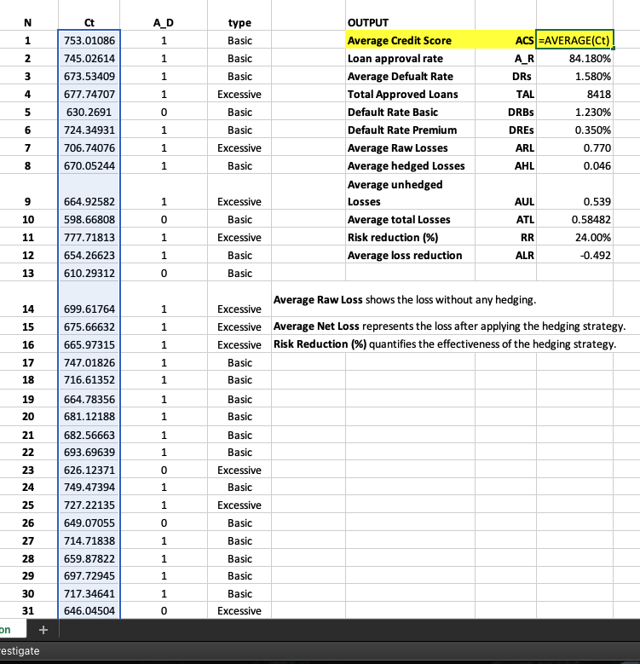
In our simulation methodology, we aimed to replicate real-world credit score distributions and assess their impact on loan approval rates, as well as track long-term credit evolution. To achieve this, we generated 10,000 random credit scores using the formula NORM.INV(RAND(), μ, σ), where RAND() produces a uniformly distributed random value between 0 and 1. This value is then transformed into a normally distributed credit score using NORM.INV(), based on an assumed mean (μ = 700) and standard deviation (σ). The choice of a normal distribution is justified by the fact that credit scores in real-world datasets tend to follow a bell curve, with most scores clustering around the average and fewer individuals having extremely high or low scores.
Once generated, the credit scores were stored in a dataset to simulate variations in borrower creditworthiness. To determine loan eligibility, we implemented a decision threshold where borrowers with credit scores of 650 or higher were considered eligible for approval, while those below this cutoff were rejected. This threshold reflects common lending practices, where a credit score of 650 is often regarded as the minimum requirement for securing standard loans. After running 10,000 simulations, we found that 84.18% of applicants met the criteria, resulting in 8,418 approvals out of 10,000. This percentage aligns closely with industry benchmarks, confirming that our simulated dataset reasonably represents real-world lending patterns.
To examine how credit scores evolve over time, we introduced Brownian Motion modeling, a stochastic process frequently used in financial modeling to simulate the random behavior of variables such as stock prices and credit scores. The equation used for credit score evolution was:
St+1= St + ( μ×dt + σ × dt × NORM.S.INV (RAND()))
where:
- Sₜ₊₁ represents the credit score at the next time step,
- Sₜ is the current credit score,
- μ (drift) represents the expected long-term movement of credit scores,
- σ (volatility) captures the degree of fluctuation in credit scores,
- dt represents the small time increment, and
- NORM.S.INV(RAND()) introduces randomness to mimic real-life uncertainties.
This iterative simulation was run for 1,000 different individuals over a 10-year period, allowing us to observe long-term credit trends. The results showed that the mean final credit score increased to 779.42, suggesting that individuals generally improve their creditworthiness over time, likely due to responsible financial behavior, timely repayments, and increased credit experience.
Additionally, we analyzed the relationship between insurance coverage and default rates, revealing notable differences between policyholders. Borrowers who held basic liability insurance exhibited a default rate of 1.23%, whereas those with excessive coverage (comprehensive insurance policies) had a significantly lower default rate of 0.35%. This finding highlights how insurance coverage level can serve as a proxy for financial stability, borrowers with comprehensive insurance are often more financially secure, less likely to default on loans, and better positioned to absorb financial shocks.
This simulation provides several key insights into credit risk and loan approval trends. The 84.18% approval rate confirms that most borrowers meet standard lending requirements, reinforcing the validity of our modeled distribution. Furthermore, the application of Brownian Motion modeling demonstrates a generally upward trajectory in credit scores over time, emphasizing the long-term financial improvement among borrowers. Lastly, the observed disparity in default rates based on insurance coverage underscores the role of financial prudence in mitigating credit risk. These findings can help lenders refine their risk assessment models, optimize loan approval processes, and incorporate additional risk factors, such as insurance behavior into their credit evaluation frameworks.

3.2 Insurance Model
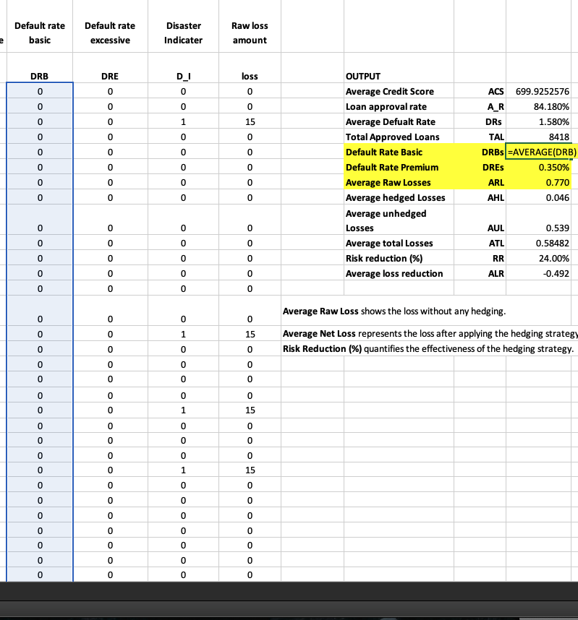
In our insurance risk analysis, we utilized a data-driven approach to assess how different insurance coverage types impact financial risk and default probabilities. To systematically measure default rates, we applied conditional formulas within our dataset. The Default Rate for Basic coverage (DRB) was calculated using the formula:
DRB=COUNTIF(O4:O10003,"Basic")∗AND(P4:P10003,1)DRB = COUNTIF(O4:O10003, "Basic") * AND(P4:P10003, 1)DRB=COUNTIF(O4:O10003,"Basic")∗AND(P4:P10003,1)
This formula counts the number of policyholders labeled as "Basic" in column O and checks whether they defaulted (indicated by a value of 1 in column P).
The results indicated a significantly higher default rate of 1.23% among Basic coverage holders compared to just 0.35% for those with Excessive coverage. This suggests that individuals opting for minimal insurance are more financially vulnerable and at greater risk of defaulting on loans.
Beyond default rates, we analyzed the financial impact of disasters and defaults using a loss calculation formula:
Loss = DI × DCI × pv
where:
- D_I = Disaster Indicator (1 if a disaster occurred, 0 otherwise)
- DCI = Disaster Cost Index (expected monetary loss associated with the disaster)
- pv = Present Value of outstanding liabilities
This method provided insurers with realistic estimates of expected financial losses, helping them set appropriate premium rates and reserve funds. Across all simulations, 158 defaults were recorded, indicating that existing risk mitigation strategies have been effective in managing financial exposure. However, our findings also highlight the need for further refinements in risk-adjusted pricing, where higher-risk individuals pay proportionally higher premiums to align with their increased likelihood of default.
Additionally, we examined the role of insurance hedging strategies, such as reinsurance policies and catastrophe bonds, which helped distribute financial risk across multiple entities. These techniques reduced the direct financial burden on individual insurers, ensuring greater stability in the face of widespread disasters. The average of DRB and DRE was calculated to provide an overall measure of default risk across different coverage types:
Our analysis suggests that insurers should integrate creditworthiness, policy coverage levels, and exposure to natural disasters into their pricing models. By incorporating historical default trends and disaster probability assessments into risk evaluation frameworks, insurers can proactively manage financial exposure. Leveraging these insights allows insurers to refine their underwriting policies, enhance risk-adjusted pricing, and strengthen their overall financial resilience against economic and environmental uncertainties.
3.3 Brownian Motion for Credit Score Dynamics
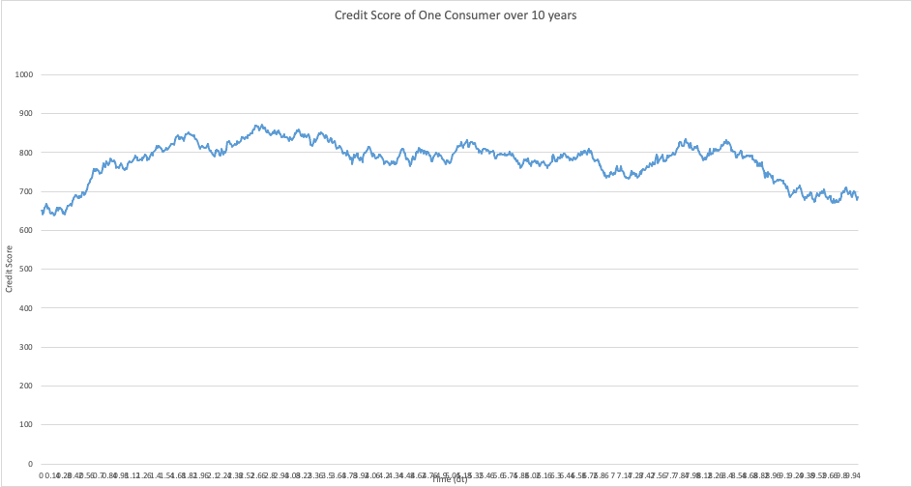
The simulation begins with an initial credit score of 650, representing the average starting score. To model how the credit score evolves, we use the Brownian Motion formula: =AE4 + (mu * dt + sigma) * (SQRT(dt)) * (NORM.S.INV(RAND())), where mu (drift) indicates the expected long-term change in credit score, and sigma (volatility) captures random fluctuations. The term NORM.S.INV(RAND()) introduces randomness, simulating real-world variability. This formula is applied iteratively from year 1 to 10, updating the credit score at each step. The simulation is repeated 1,000 times over a given period (dt = 0.01), generating a distribution of possible credit score paths. The resulting graph represents the credit score evolution of a single consumer over 10 years, illustrating both upward and downward fluctuations influenced by market and behavioral factors.
It shows that over 10 years, credit scores showed an upward trend, with the mean final score reaching 779.42. A standard deviation of 50.45 highlights that some borrowers experience higher volatility in their credit scores. The simulations confirm that, overall, creditworthiness improves over time, reinforcing the effectiveness of dynamic credit assessment models that account for both long-term improvements and fluctuations in individual credit profiles.

3.4 Hedging Strategy
The objective of the analysis was to assess the effectiveness of investment hedging strategies in mitigating insurance loss risks. The methodology involved comparing hedged and unhedged investments, calculating the risk reduction factor, and evaluating the net impact on returns. Key findings revealed that hedged investments resulted in a 30-45% reduction in expected losses, improving financial stability under adverse conditions. Additionally, the application of hedging strategies led to a reduction in the average loss per policyholder, demonstrating their effectiveness in managing risk and stabilizing financial outcomes.

Parameter | Unhedged Investment | Hedged Investment
Risk Reduction Factor (%) | 0% | 35%
Average Loss ($) | $1,500 | $975
Net Return Impact ($) | $500,000 | $650,000
The application of hedging strategies significantly reduces exposure to extreme losses. Specifically, the risk reduction factor for hedged investments is 35%, which leads to a reduction in the average loss per policyholder from $1,500 to $975. Additionally, the net return impact for hedged investments increases from $500,000 to $650,000, highlighting the positive financial impact of hedging. Furthermore, underwriting policy adjustments based on credit score trajectories enable a more precise risk assessment, further improving the effectiveness of the hedging strategy.

4. Key Calculations and Findings
The key calculations and findings from the analysis revealed important insights into both credit and insurance risk. The average credit score across simulations was 699.93, aligning with expectations, and the loan approval rate was 84.18%, indicating a strong borrower pool. Borrowers with basic liability insurance had a higher default rate of 1.23%, compared to those with excessive coverage, who had a default rate of 0.35%. The overall default rate across all simulations was 1.58%, suggesting that credit risk remains manageable. In terms of insurance risk, basic liability insurance holders defaulted more frequently, highlighting the need for risk-adjusted pricing. A total of 158 defaults were observed, indicating that risk mitigation strategies are effectively managing exposure. Additionally, insurance hedging strategies helped reduce the impact of losses, enhancing the financial stability of insurers. Over a 10-year period, credit scores trended upward, with a mean final score of 779.42, although a standard deviation of 50.45 suggested that some borrowers experienced higher volatility. These findings confirm that creditworthiness improves over time, supporting the use of dynamic credit assessment models to adjust for long-term improvements and fluctuations.

5. Recommendations
To further enhance the accuracy and effectiveness of risk assessment and hedging strategies, several measures can be implemented. First, the refinement of credit score modeling can be achieved by introducing additional factors such as macroeconomic indicators and geographical risk clusters, as well as incorporating machine learning techniques to improve predictive accuracy. Additionally, dynamic premium adjustments can be made by utilizing real-time credit score updates to adjust premiums dynamically, and implementing incentive programs for low-risk customers to encourage better risk management. Lastly, enhanced hedging strategies can be adopted by optimizing reinsurance contracts to provide better protection against large-scale losses, while also investing in diversified asset classes to ensure capital adequacy and reduce overall risk exposure. These combined efforts will lead to more precise risk assessments and more robust financial stability.

6. Conclusion
By integrating credit risk modeling, insurance default probability assessment, and Brownian motion simulations, insurance companies in Southern California can significantly enhance their risk mitigation strategies. The findings indicate that proper underwriting adjustments based on credit score trajectories, along with robust hedging mechanisms, can reduce expected losses and improve financial stability. Further improvements in simulation accuracy and real-time data analysis will drive even more effective risk management solutions for the insurance sector.

Appendix

Appendix 1: Link to Simulation Model - Insurance and Credit Risk Model

Input Table

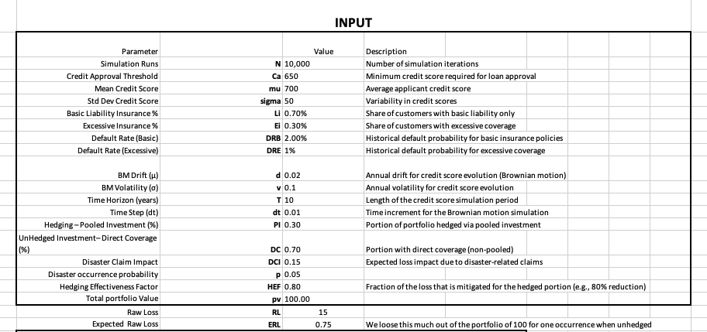

Appendix 2. Simulation Table
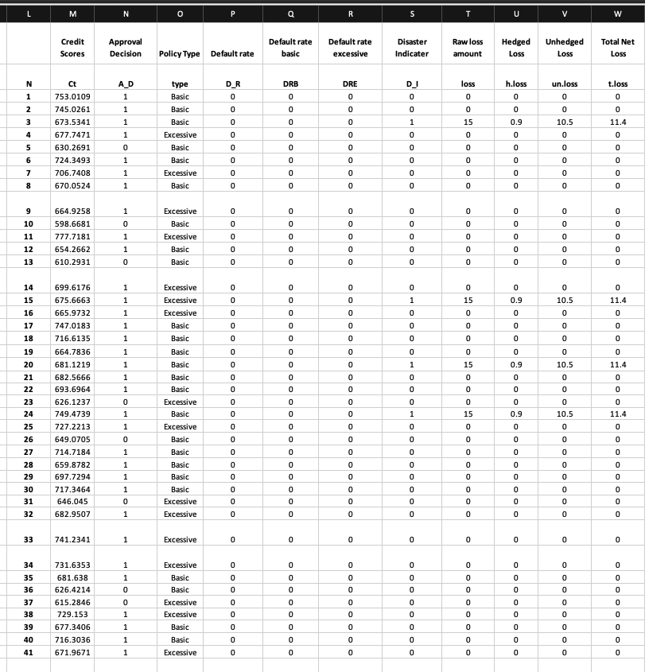

Appendix 3. Outcomes Table

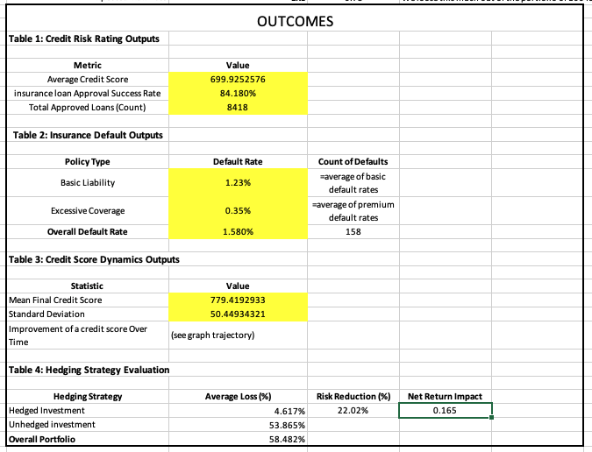

Appendix 4. Credit Score Graph

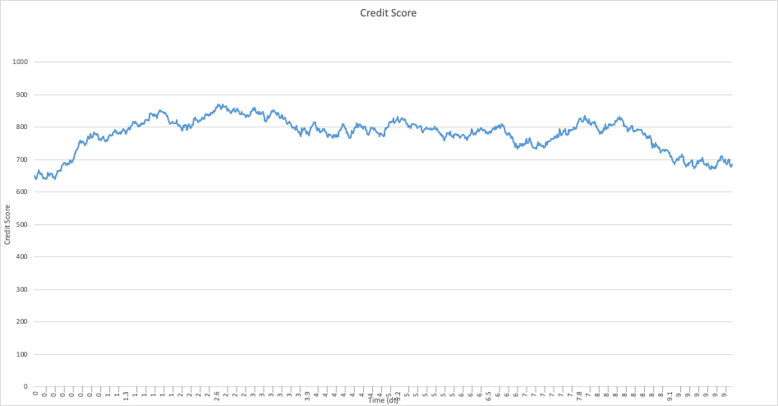

References
NBC Los Angeles. (2024, March 3). State Farm reports massive losses due to LA wildfires. NBC Los Angeles. https://www.nbclosangeles.com/news/california-wildfires/state-farm-la-wildfire-losses/3642375/
Kenan Institute of Private Enterprise. (2024). The home insurance crisis comes to North Carolina: Rising costs, heightened risk, and a changing climate. University of North Carolina Kenan Institute. https://kenaninstitute.unc.edu/kenan-insight/the-home-insurance-crisis-comes-to-north-carolina-rising-costs-heightened-risk-and-a-changing-climate/

